House Price Estimator
House Price Prediction using Linear Regression

1. Objective
To build and evaluate a Linear Regression model using the California Housing dataset and understand the complete machine learning workflow including data loading, exploration, preprocessing, training, prediction, and evaluation.

2. Dataset Overview
The California Housing dataset (built into scikit-learn) was used. It contains 20,640 rows and 9 columns describing housing characteristics across California districts, with the goal of predicting the median house value (in $100,000s) for each district.
Feature | Description
MedInc | Median income of households in the area ($10,000s)
HouseAge | Median age of houses in the area (years)
AveRooms | Average number of rooms per household
AveBedrms | Average number of bedrooms per household
Population | Population of the area
AveOccup | Average number of people per household
Latitude | Geographic latitude of the area
Longitude | Geographic longitude of the area
MedHouseVal | Target: Median house value ($100,000s)
A check for missing values confirmed the dataset is complete: all 9 columns have 20,640 non-null entries, so no imputation was required.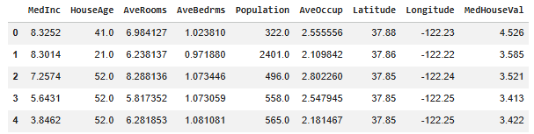
Figure 1:First 5 rows of the dataset (df.head()).

3. Exploratory Data Analysis (EDA)

Target Distribution
The distribution of the target variable (median house value) is right-skewed, with a noticeable spike at the upper boundary of $500,000 — a known artifact of this dataset, where values were capped at that level during collection.
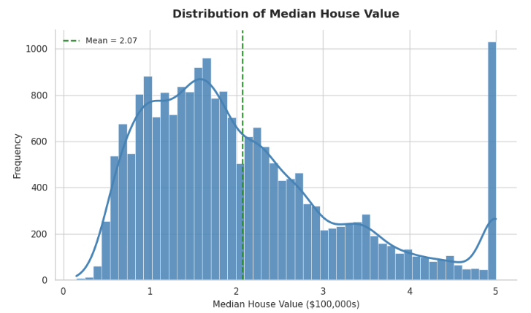
Figure 2: Distribution of Median House Value, with mean marked.

Feature Distributions
Most features are heavily skewed, with a few extreme outliers visible in AveRooms, AveBedrms, Population, and AveOccup.

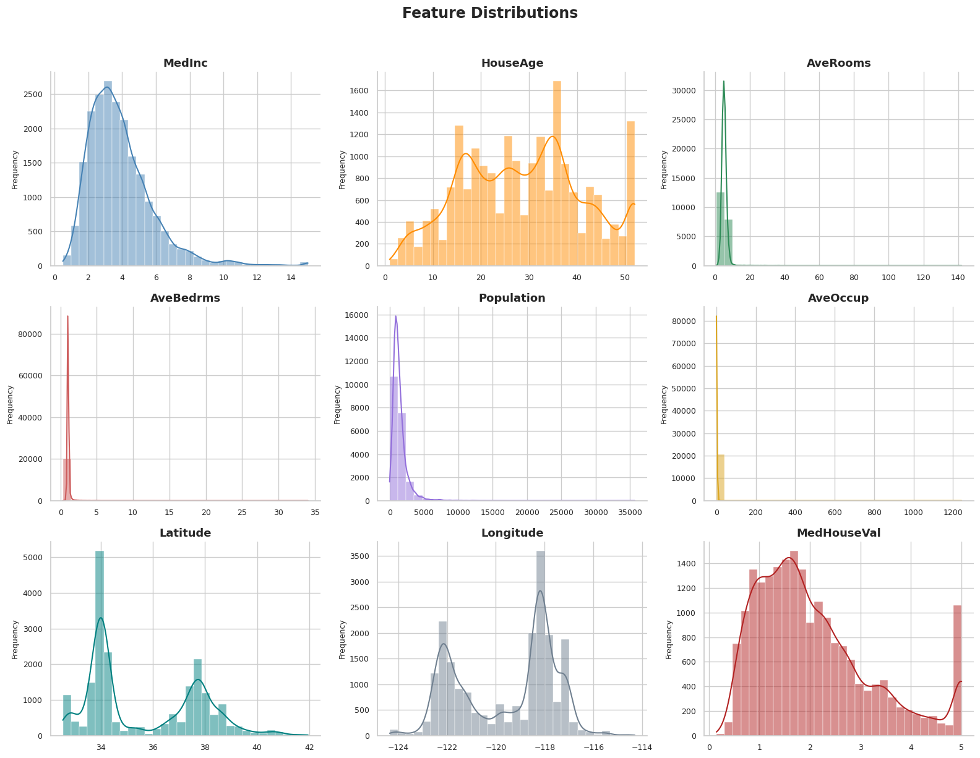
Figure 3 : Feature Distributions.

Correlation Analysis
Median Income (MedInc) stood out as by far the strongest predictor of house value, which aligns with real-world intuition — wealthier areas tend to have more expensive homes. All other features showed weak correlation individually.
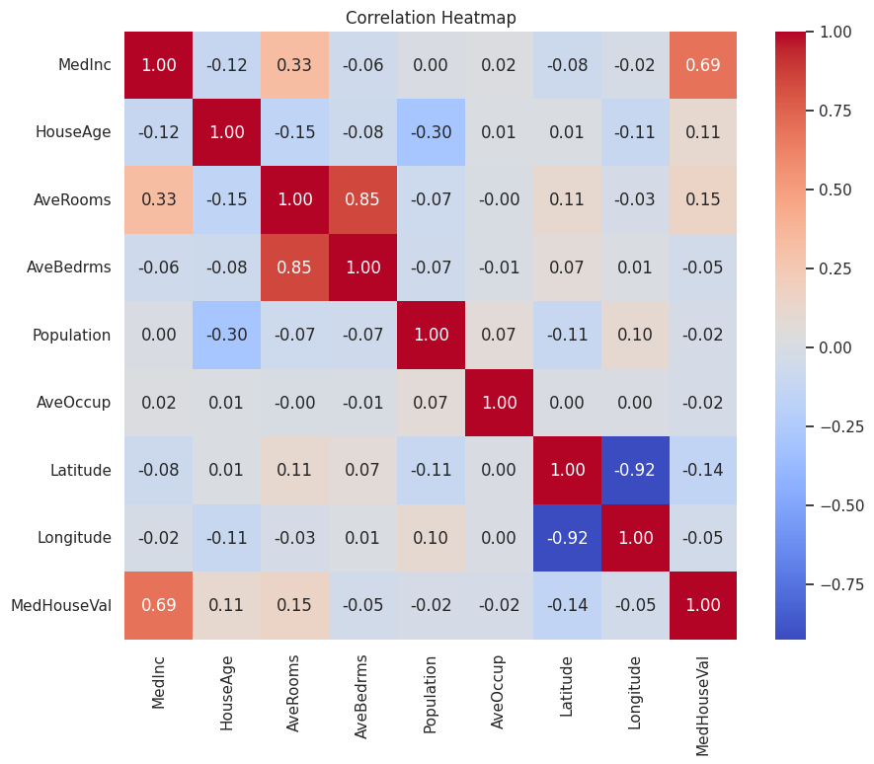
Figure 4 : Correlation heatmap across all features and the target.
Feature | Correlation with MedHouseVal
MedInc | 0.688
AveRooms | 0.152
HouseAge | 0.106
AveOccup | -0.024
Population | -0.025
Longitude | -0.046
AveBedrms | -0.047
Latitude | -0.144

4. Data Preparation
All 8 features were used as predictors, with MedHouseVal as the target. The data was split into a training set (80%) and a test set (20%) using a fixed random seed for reproducibility.
Set | Rows | Columns
Training | 16,512 | 8
Testing | 4,128 | 8

5. Model Training & Evaluation
A Linear Regression model was trained on the training set and evaluated on the held-out test set using three standard regression metrics:
Metric | Value | Meaning
MAE | 0.533 | Average absolute prediction error (~$53,300)
RMSE | 0.746 | Root mean squared error (~$74,600); penalizes larger errors more
R² Score | 0.576 | The model explains about 57.6% of the variance in house prices

These results are consistent with the well-known performance ceiling of plain linear regression on this dataset — an R² of roughly 0.55 to 0.60 is the expected range, since house prices depend on non-linear factors (e.g. location clusters, interaction effects) that a simple linear model cannot capture.

Model Coefficients
The table below shows how much each feature influences the predicted price, holding other features constant. Note that coefficient size depends on each feature's own scale, so it should not be directly compared to correlation strength.
Feature | Coefficient
AveBedrms | 0.783
MedInc | 0.449
HouseAge | 0.010
Population | -0.000002
AveOccup | -0.004
AveRooms | -0.123
Latitude | -0.420
Longitude | -0.434
Model Intercept: -37.023

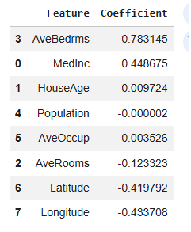

6. Visualizations

Actual vs Predicted
Compares the model's predicted house values against the true test-set values. Points would lie exactly on the red diagonal line for a perfect model; the observed spread confirms the model captures the general price trend but with noticeable error, matching the R² of 0.576. Note the vertical band of points near the far right, caused by the price-cap artifact in the data.

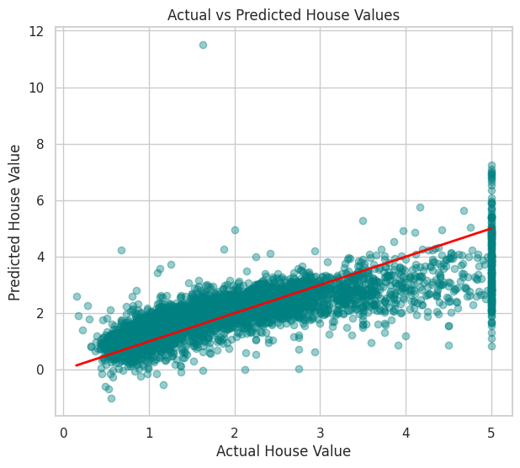
Figure 5 : Actual vs Predicted house values (red line = perfect prediction).

Residuals Distribution
Shows the spread of prediction errors (actual minus predicted). The residuals are roughly centered around zero, indicating the model is not strongly biased toward over- or under-predicting on average, though the distribution has some spread and a long tail from the capped house values.

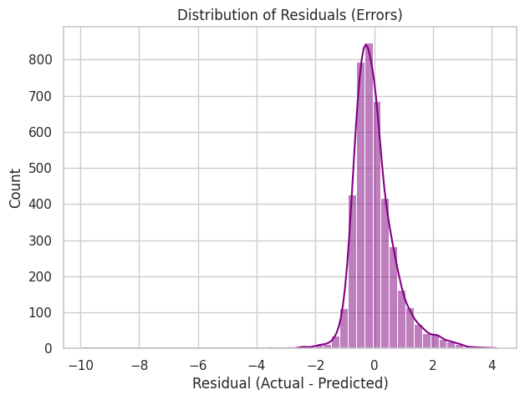
Figure 6 : Distribution of residuals (prediction errors).

Residuals vs Predicted Values
Used to check whether prediction errors grow or shrink systematically across the price range. A downward-sloping pattern is visible rather than a random scatter, suggesting the model tends to under-predict at higher price levels — a common limitation of linear regression on data with non-linear relationships.

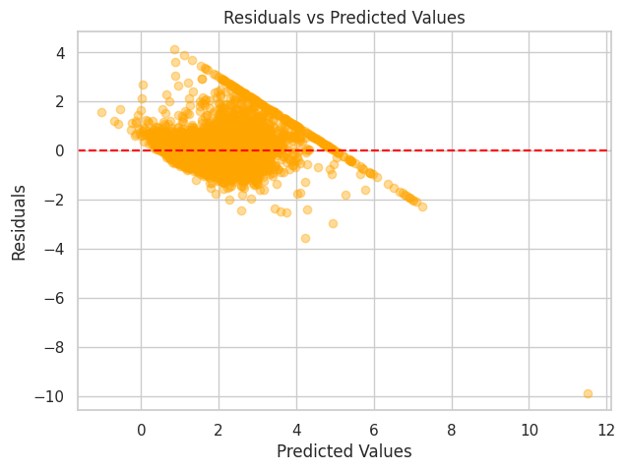
Figure 7 : Residuals plotted against predicted values.

7. Model Deployment
The trained model was saved to disk as a pickle file (house_price_model.pkl) so it can be reloaded without retraining. A small prediction function and an interactive widget-based UI were also built, allowing a user to enter neighborhood details (income, house age, rooms, location, etc.) and instantly receive a predicted median house price.
Example: for a sample input (median income $50,000, house age 25 years, 6 average rooms, 1 average bedroom, population 1,000, 3 people per household, location near Los Angeles), the model predicted a median house value of approximately $239,840.67.

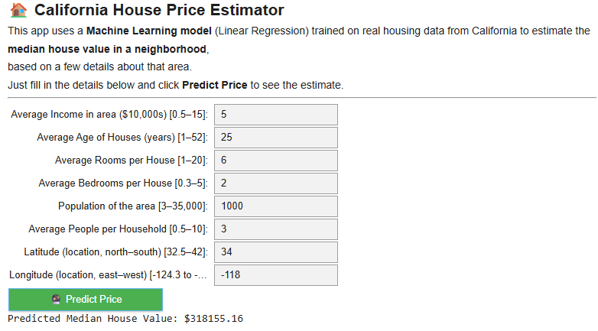
Figure 8 : Interactive UI — example prediction with default input values.

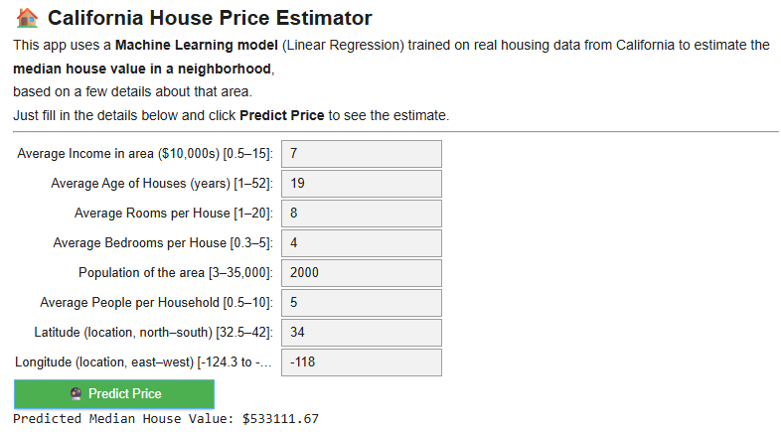
Figure 9 : Interactive UI — a second test with different input values.

8. Conclusions & Improvement Ideas
The Linear Regression model achieved an R² of 0.576, meaning it explains roughly 58% of the variability in California house prices using only 8 simple features. Median income was the single most influential factor. While the model provides a reasonable baseline, several improvements could increase accuracy:
- Feature scaling (e.g. StandardScaler) to make coefficients directly comparable and improve numerical stability.
- Engineering new features, such as rooms-per-household or distance to the nearest city center, to capture location effects better than raw latitude/longitude.
- Trying non-linear models (Random Forest, Gradient Boosting, or XGBoost), which typically achieve R² scores of 0.75-0.85+ on this dataset.
- Removing or capping outliers, especially the artificially capped house values at $500,000, which distort error metrics.
- Applying cross-validation instead of a single train/test split for a more robust estimate of model performance.

